### [**Shower Party Decorations with a Sliceform Heart and a Sliceform Wedding Bell**](https://papercraftetc.blogspot.com/2017/07/shower-party-decorations-with-sliceform.html)

I had a wedding shower party at my house for my daughter. Of course, I had to make paper decorations. Here are a few of the decorations.. a sliceform heart and a sliceform wedding bell.

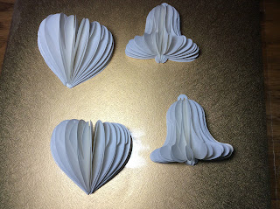

Sliceform Heart and Wedding Bell

The slice form wedding bell and slice form heart have similar directions as the slice form bride. Please refer to those directions to <http://papercraftetc.blogspot.com/2017/03/slice-form-bride-and-groom-cake-topper.html> Slide one slit into another...first the bottom slit and then the top slit...stacking them one on top of another as you go. Tape the outside edge and then glue to the backing. I use two backings to give it extra support.

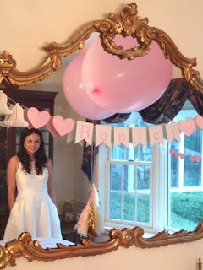

Happy Wedding Shower Day!